**ST.XAVIER’S COLLEGE**

MAITIGHAR, KATHMANDU



Computer Graphics

Assignment #4

Submitted By:

Prashraya Hada

013BSCCSIT027

2nd Year/ 4th Sem

Submitted to:

|  |  |
| --- | --- |
| Er. Anil K. Sah  Lecturer  Department of Computer Science |  |

Date of Submission: 18th August, 2015

**Statement:**

Write a program to draw a line using BLA algorithm in C++ builder.

**Algorithm:**

1. Input the two line endpoints and the left endpoint at (x0,y0)
2. Load (x0,y0) into frame buffer, i.e. plot the first point.
3. Calculate constants 2∆x, 2∆y and obtain first decision parameter p0 = 2∆y – ∆x
4. At each xk along the line, starting at k = 0, perform the following test,

If pk < 0, next point is (xk+1,yk) and pk+1 = pk + 2∆y

Otherwise, next point to plot is (xk+1,yk+1) and pk+1 = pk + 2∆y – 2∆x

1. Repeat step 4 ∆x times.

**Source Code:**

//---------------------------------------------------------------------------

#include <vcl\vcl.h>

#pragma hdrstop

#include "bla.h"

//---------------------------------------------------------------------------

#pragma resource "*.dfm"

int x,y,x1,y1,x2,y2,dx,dy,p,pk ,i,xEND;

TForm1 *Form1;

//---------------------------------------------------------------------------

__fastcall TForm1::TForm1(TComponent* Owner)

: TForm(Owner)

{

}

//---------------------------------------------------------------------------

void __fastcall TForm1::Button1Click(TObject *Sender)

{

x1=StrToInt(Edit1->Text);

x2=StrToInt(Edit2->Text);

y1=StrToInt(Edit3->Text);

y2=StrToInt(Edit4->Text);

dx=abs(x2-x1);

dy=abs(y2-y1);

if(x1>x2)

{

x=x2;

y=y2;

xEND=x2;

}

else

{

x=x1;

y=y1;

xEND=x2;

}

Image1->Canvas->Pixels[x][y]=RGB(0,255,0);

pk=2*dy-dx;

while(x<=xEND)

{

if(pk<0)

{

x=x+1;

y=y;

pk=pk+2*dy;

}

else

{

x=x+1;

y=y+1;

pk=pk+2*dy-2*dx;

}

Image1->Canvas->Pixels[x][y]=RGB(0,255,0);

}

}

//---------------------------------------------------------------------------

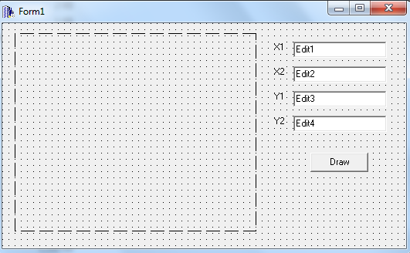

**Output:**

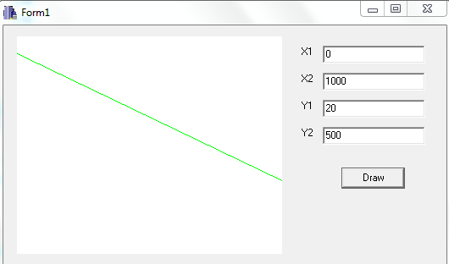

**Conclusion:**

Hence, using C++ builder, BLA algorithm was implemented.